VINAYAKA MISSION’S COLLEGE OF NURSING, KARAIKAL
REPORT ON SWACHH BHARAT ABHIYAN ACTIVITIES -2018
Our Vinayaka Mission’s College of Nursing, Karaikal inaugurated the summer internship programme “SWACHH BHARAT ABHIYAN ACTIVITIES - 2018” from 05 – 05 -2018 to 28- 05- 2018 in Jeeva Nagar ,Kottucherry an adopted rural area . The B.Sc.,(N) students actively participated in creating awareness among the public about keeping the environment clean by villupattu, distribution of pamphlets by House to House, chart exhibition on importance of Environmental Sanitation , Safe drinking water, Hand washing techniques and usage of toilet for defaecation, Rally was conducted on environmental cleanliness. The students have taken initiative and cleaned up the street, Road & temple premises of Jeeva Nagar Village. The volunteers from campaign made an inspiring wall painting on Environmental hygiene. This programme distributed the responsibilities of cleanliness among each and every person in the village and an exercises which took the determination towards the dream of clean & Healthy India.
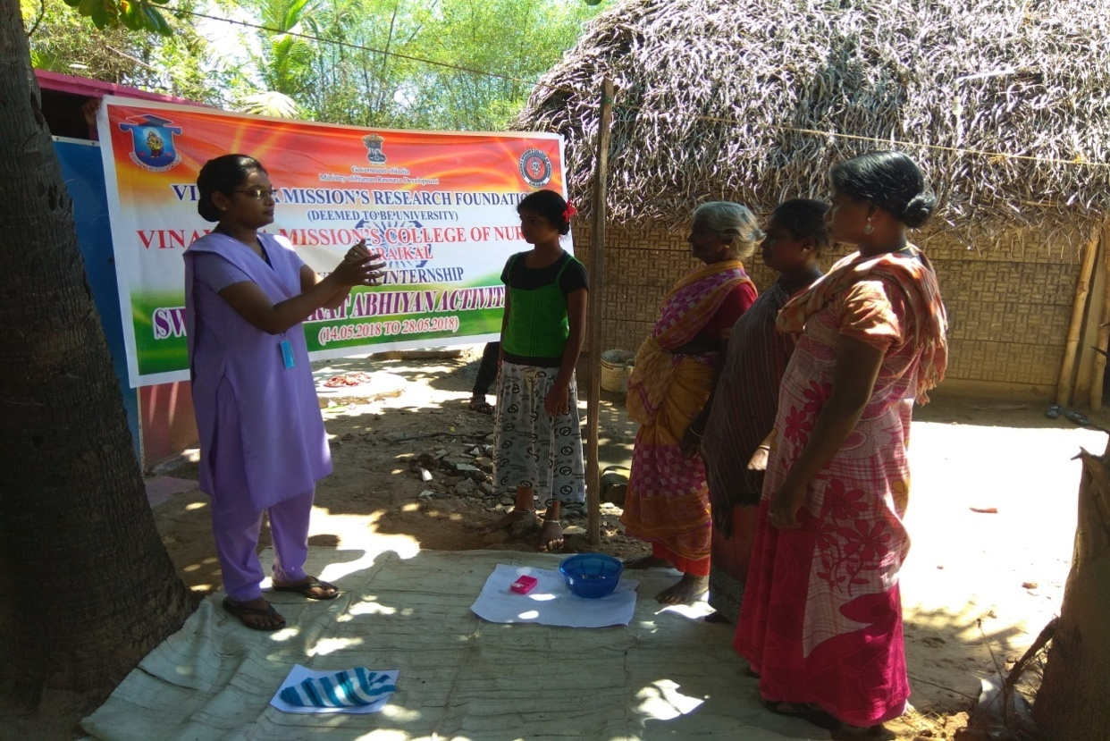

A Student explaining the Hand Washing Techniques to the village
people
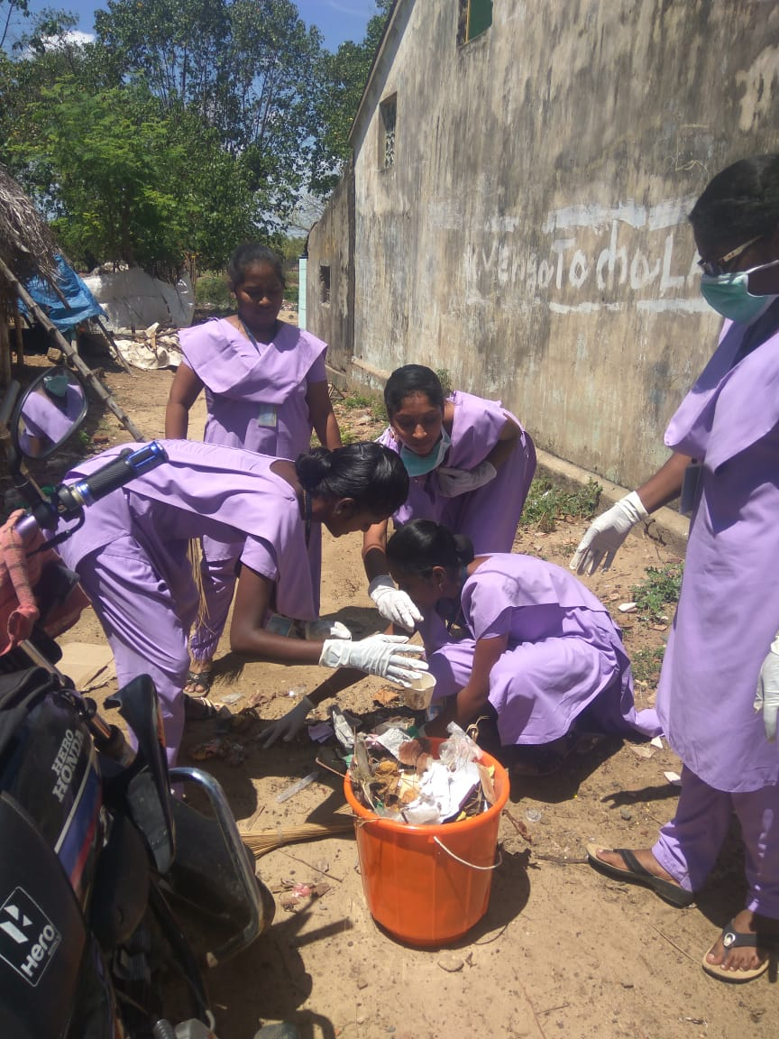

Our Students Cleaning the Jeeva Nagar Area, Karaikal
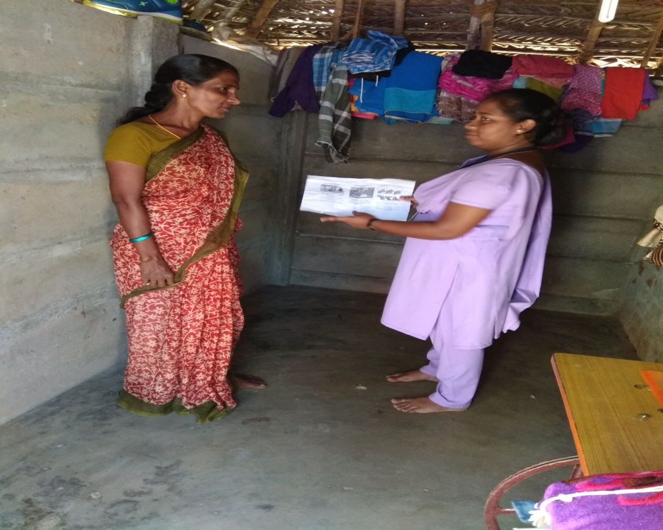

Our Students Issuing the pamphlets regarding using toilets.

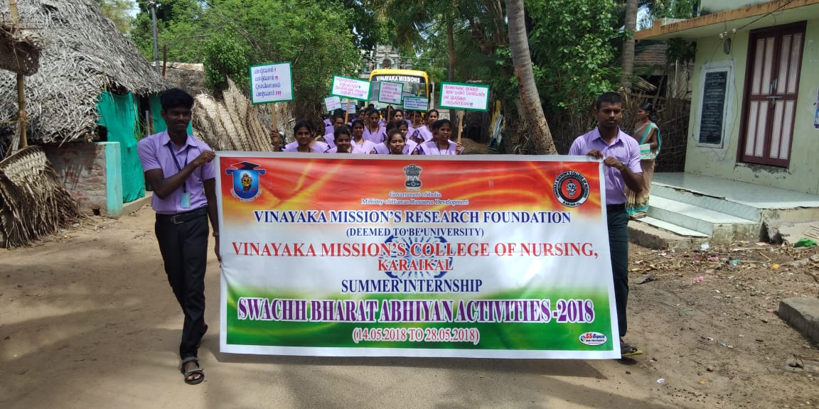
Rally was conducted on environmental cleanliness.
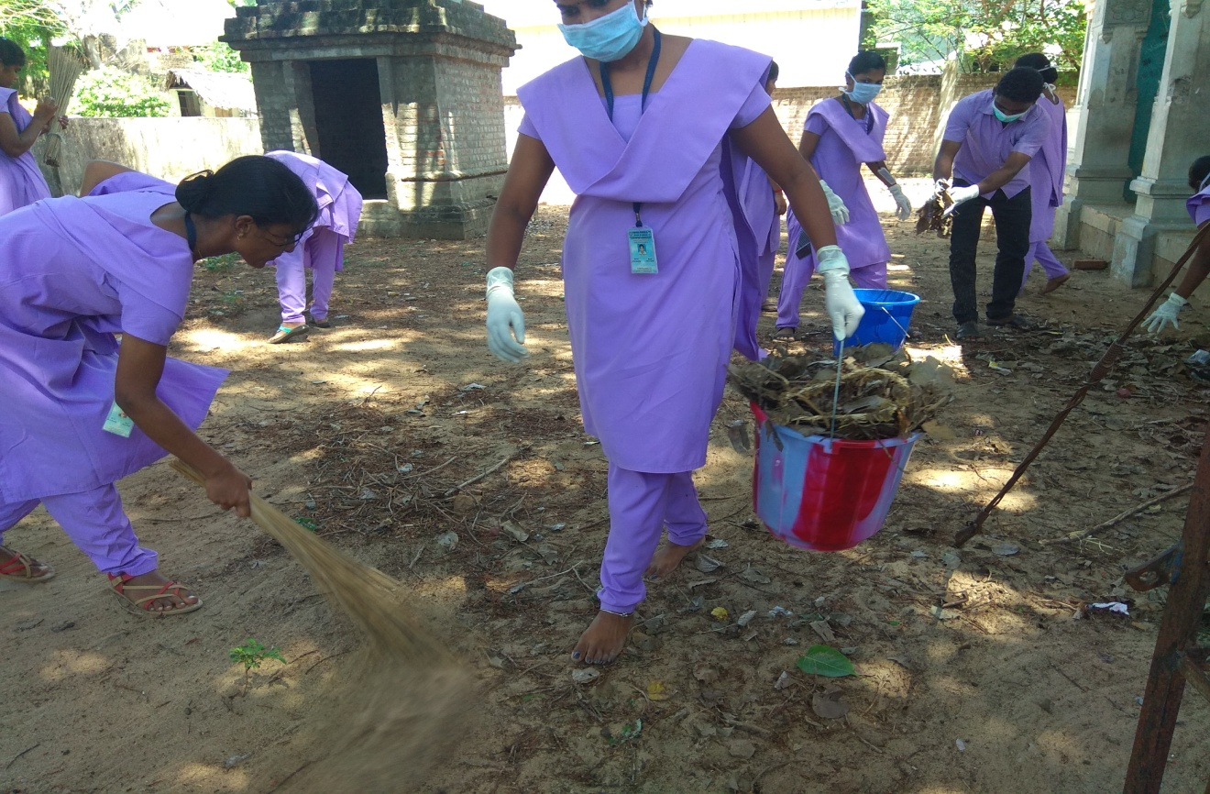

Our Students Cleaning the Jeeva Nagar Area, Karaikal

